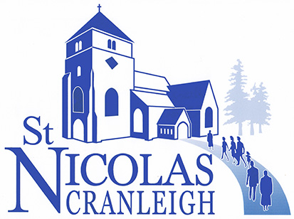

UNITED IN PRAYER

Some suggestions for Evening Prayer at Home

(Remember, we are not praying alone, but as
part of a community at prayer in the parish)

Preparation

Behold, God is my helper; it is the Lord who upholds my life
Psalm 54: 4

You also shall light my candle; the Lord my God shall make my darkness to be bright
Psalm 18: 28

That this evening may be holy, good and peaceful, let us pray with one heart and mind.

As our evening prayer rises before you, O God, so may your mercy come down upon us to cleanse our hearts and set us free to sing your praise, now and for ever. Amen

Common Worship

Praise
I come from God,
The source of all life
And ground of my being…

I belong to God,
My Lord and Saviour,
My life,
My strength and inspiration…

I am going to God,
My purpose and fulfilment,
My goal and destination…

In God I live and move and have my being.

Almighty and eternal God,
In whom we live and move and have our being,
We worship you in all the fullness of your revelation to us:
You are the source of all life and the ground of our being…
The Word made flesh who came to dwell among us…
The Holy Spirit who strengthens and inspires us.
Deepen our knowledge and increase our faith,
And help us to proclaim you to the world
As Father, Son and Holy Spirit,
One God, now and for ever. Amen Anon
Free Prayers of Thanksgiving:-

For the day that has just passed…

For the people we have met today…

For the unexpected encounters…

For health and strength - for house and home…

For every blessing

Scripture Readings

A psalm

A reading from the Old or New Testament – perhaps with the use of a commentary
(e.g.Tom Wright’s ‘for Everyone’ series, pub. SPCK) or Bible reading notes

A time of Reflection – on one or more of the following:-

The Bible Reading

The day’s headlines in the newspaper or a media website

An article or extract from a Christian publication (e.g. Bible Society, USPG, Christian Aid)

The Parish Sunday News Sheet List of Events

Our personal diary for the day

Prayers of Intercession. Perhaps choose one or two sections each day:-

For the world – the leaders of the nations – justice, peace and reconciliation.

For the worldwide church – Christians in areas where the church is thriving – Christians who are persecuted – those who work overseas with Christian charities and mission societies.

For those who live and work in Cranleigh (using the parish Cycle of Prayer). For the doctors and nurses in the Medical Centre – those who work for the emergency services – those who serve us in the shops, supermarkets and Thursday market. Our schools.

For our fellow Christians in Cranleigh as they seek to serve God in their daily lives. For Roy our Rector and the Ministry Team, the Churchwardens and members of the PCC. For our brothers and sisters who belong to the other churches in the village.

For all who suffer – those caught up in war or civil strife – those in fear of their lives – refugees and asylum seekers. For those who are sick or in trouble – the lonely or bereaved, especially… All who find life hard.

For our families, friends and all whom we love…

For any individuals or situations about which we are particularly concerned…

The Lord’s Prayer

Night Prayers

Save us, O Lord, while waking,
And guard us while sleeping,
That awake we may watch with Christ
And asleep we may rest in peace.

Be present, O merciful God,
And protect us through the silent hours of this night,
So that we who are wearied
by the changes and chances of this fleeting world,
May rest upon your eternal changelessness;
Through Jesus Christ our Lord.

In peace we will lie down and sleep;
For you alone, Lord, make us dwell in safety.

The Lord bless us and watch over us;
The Lord make his face shine upon us and be gracious to us;
The Lord look kindly on us and give us peace. Amen

Common Worship – Compline

Closing Prayer

On my heart and on my house
The blessing of God.
In my coming and in my going
The peace of God.
In my life and in my seeking
The love of God.
At my end and new beginning
The arms of God to welcome me
And bring me home.
J. Philip Newell: Celtic Prayers

