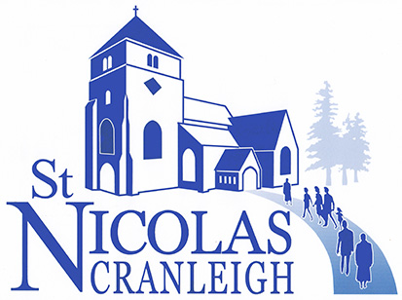

UNITED IN PRAYER
Some suggestions for Morning Prayer at Home
(Remember, we are not praying alone, but as
part of a community at prayer in the parish)

Preparation
This is the day that the Lord has made; we will rejoice and be glad in it
Psalm 118: 24

Wait on God in stillness, O my soul
Psalm 62: 5

The night has passed and the day lies open before us. Let us pray with one heart and mind.

As we rejoice in the gift of this new day, so may the light of your presence, O God, set our hearts on fire with love for you, now and for ever. Amen

Common Worship
Praise

Lord of the universe
God above us and beyond us
Source of all life

Ground of our being
I worship and adore you

Lord Jesus Christ
God in the midst of us
Word made flesh
Loving Saviour
I worship and adore you

Holy Spirit of God
God within us and around us
Breath of life
Our strength and inspiration

I worship and adore you

Almighty and Eternal God,
In whom we live and move
and have our being,
Father, Son and Holy Spirit

I worship and adore you

Anon

Thanks be to you, O God,
that I have risen this day
to the rising of this life itself.
May it be a day of blessing,
O God of every gift,
a day of new beginnings given.
Help me to avoid every sin
and the source of every sin to forsake,
and as the mist scatters
from the crest of the hills
may each ill haze clear
from my soul, O God.
J.Philip Newell: Celtic Prayers

Free Prayers of Thanksgiving:-

For the night that has just passed and the gift of sleep…

For the new day – a day that is special and unique…

For all that happened yesterday…

For health and strength - for house and home…

For family and friends – and all whom we might meet today…

Scripture Readings

A psalm

A reading from the Old or New Testament – perhaps with the use of a commentary
(e.g.Tom Wright’s ‘for Everyone’ series, pub. SPCK) or Bible reading notes

A time of Reflection – on one or more of the following:-

The Bible Reading

The day’s headlines in the newspaper or a media website

An article or extract from a Christian publication (e.g. Bible Society, USPG, Christian Aid)

The Parish Sunday News Sheet List of Events

Our personal diary for the day

Prayers of Intercession. Perhaps choose one or two sections each day:-

For the world – the leaders of the nations – justice, peace and reconciliation.

For the worldwide church – Christians in areas where the church is thriving – Christians who are persecuted – those who work overseas with Christian charities and mission societies.

For those who live and work in Cranleigh (using the parish Cycle of Prayer). For the doctors and nurses in the Medical Centre – those who work for the emergency services – those who serve us in the shops, supermarkets and Thursday market. Our schools.

For our fellow Christians in Cranleigh as they seek to serve God in their daily lives. For Roy our Rector and the Ministry Team, the Churchwardens and members of the PCC. For our brothers and sisters who belong to the other churches in the village.

For all who suffer – those caught up in war or civil strife – those in fear of their lives – refugees and asylum seekers. For those who are sick or in trouble – the lonely or bereaved, especially… All who find life hard.

For our families, friends and all whom we love…

For any individuals or situations about which we are particularly concerned…

The Lord’s Prayer

A Prayer of Dedication

All through this day, O Lord,
Make use of me as your servant.

May I be ready for all that this day brings.
May I live each moment to your honour and glory.
May I meet you in every encounter.

May every life I touch
Be moved by your Holy Spirit,
Whether through the word I speak,
The prayer I breathe
Or the life I live in the name of Jesus. Amen
Based on a prayer by Mary Sumner
Closing Prayers

God be in my head, and in my understanding;
God be in my eyes, and in my looking;
God be in my mouth, and in my speaking
God be in my heart, and in my thinking
God be at mine end, and at my departing.
Sarum Primer

The Lord bless us and preserve us from all evil, and keep us in eternal life. Amen
Common Worship

